**Stage 5 – Signs**

**RULES:** USPSA Competition Rules, Latest Edition **COURSE DESIGNER:** John Royer

|  |  |
| --- | --- |
| **START POSITION:** Both feet on the Shooting Sports Innovation Xs, facing downrange.  **Handgun**: Loaded and holstered, hands touching marks. **PCC**: Loaded, muzzle touching one of the marks. | |
| **STAGE PROCEDURE**  See written stage briefing. | **SCORING**  **SCORING:** Comstock 26 rounds.  **TARGETS:** 11 cardboard targets, 4 steel targets  **SCORED HITS:** 2 Best hits per carboard will be scored. Steel must fall to score.  **START-STOP:**  Audible - Last shot  **PENALTIES:** Per USPSA Competition Rules |

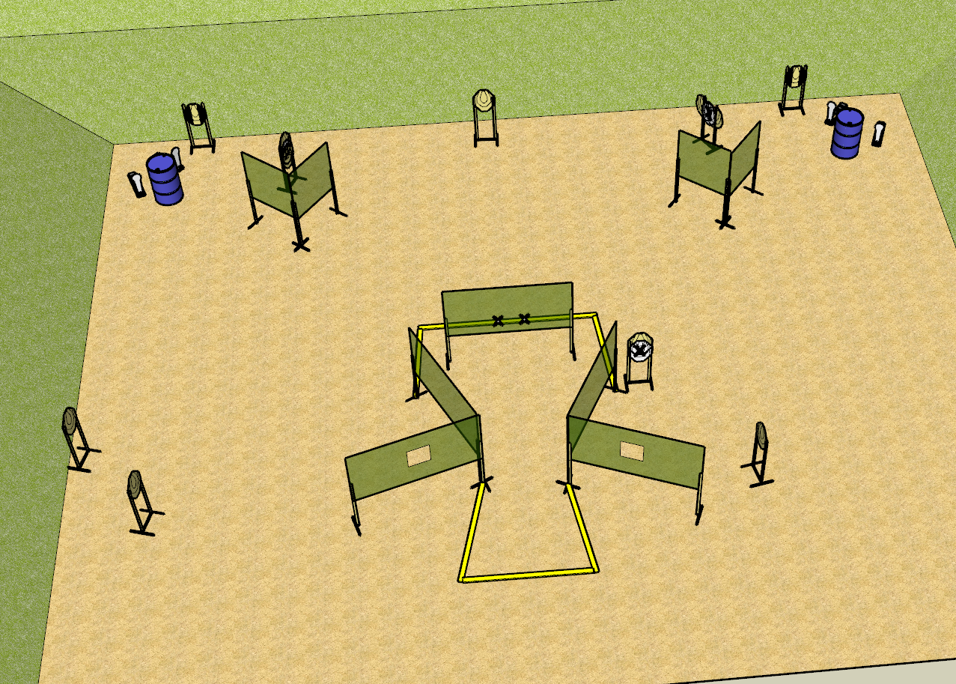

**Written Stage Briefing:**

**Stage 5 – Signs –** is a 26-round, 130 point, Comstock Long Course. There are 11 cardboard targets and 4 steel targets. The best 2 hits per cardboard target will be scored. Steel must fall to score.

**Start position**

**Handgun**: Loaded and holstered, hands touching marks.

**PCC**: Loaded, muzzle touching one of the marks.

On the audible start signal, engage targets from within the shooting area.

**Setup Notes:**

10 Single Wall Stands

4 Double Wall Stands

3 Full Size Walls

2 Ported Walls

4 Half Walls

9 Target Stands / 18 Target Sticks

2+ Barrels

Tape for Xs

- Outer steel and tuxes to be engaged through the window only, then disappear

- Inner steel to only appear once you cross the into the middle of the shooting area and not be visible anywhere else